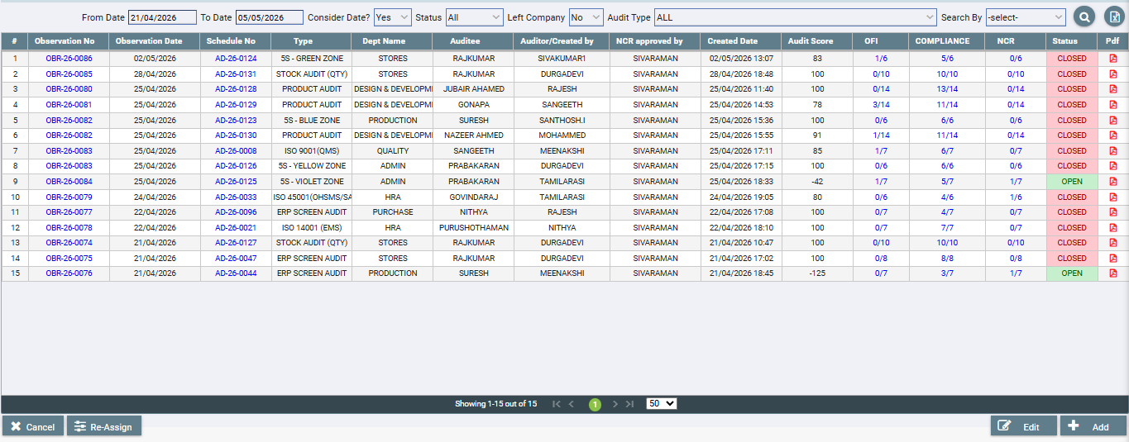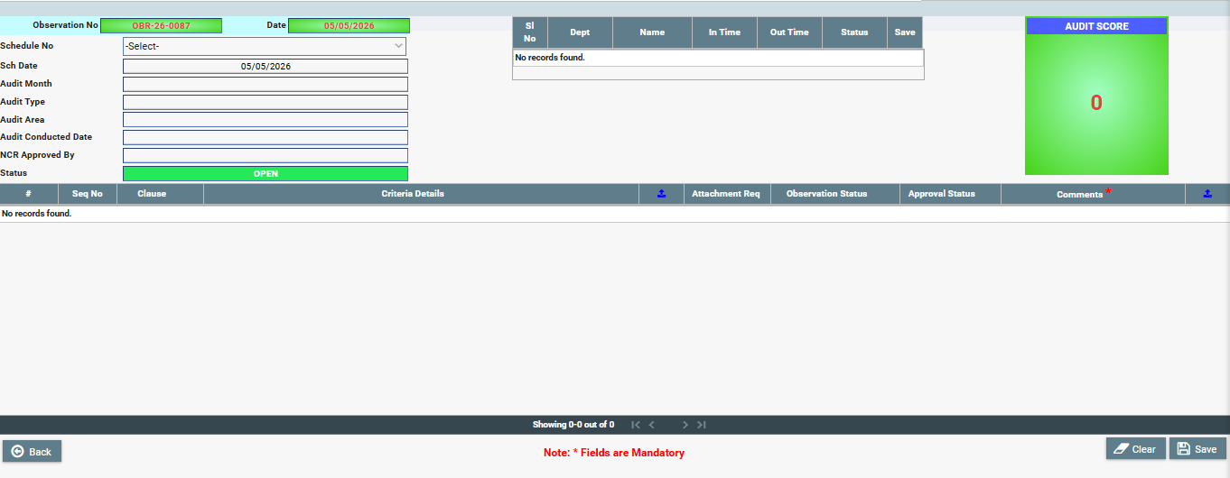

SOP: Audit Observation

1. Objective
To manage audit observations, including:
- Recording audit findings (Observation No)
- Linking with Audit Schedule
- Tracking OFI / Compliance / NCR
- Managing approval and closure status
- Calculating Audit Score

2. Module Structure
Pages
- Summary Page (Observation List)
- Creation / Edit Page (Observation Entry Form)

3. Summary Page (Observation List View)
3.1 Purpose
Display all audit observations with status tracking and metrics.

3.2 Fields to Display
- Observation No
- Observation Date
- Schedule No
- Audit Type
- Department
- Auditee
- Auditor / Created By
- NCR Approved By
- Created Date
- Audit Score
- OFI Count
- Compliance Count
- NCR Count
- Status (OPEN / CLOSED)
- PDF Icon (Download report)

3.3 Filters
- From Date / To Date
- Consider Date (Yes/No)
- Status (OPEN / CLOSED / ALL)
- Audit Type
- Left Company (Yes/No)
- Search By (Observation No / Schedule No / Name)

3.4 Features
Actions
- Add (+) → Open Creation Page
- Edit → Modify selected observation
- Re-Assign → Change auditor/auditee
- Cancel → Exit screen
- PDF Download → Export report

Grid Behavior
- Clickable Schedule No / Observation No
- Color indicators:
  - RED → CLOSED
  - GREEN → OPEN

Pagination
- 10 / 20 / 50 records per page

4. Creation / Edit Page (Form View)

4.1 Header Section
Field | Type | Mandatory | Description
Observation No | Auto | Yes | Auto-generated (e.g., OBR-26-0087)
Date | Date Picker | Yes | Current date default
Schedule No | Dropdown | Yes | Linked audit schedule

4.2 Auto-Fetch Fields (Read Only)
When Schedule No is selected, fetch:
- Schedule Date
- Audit Month
- Audit Type
- Audit Area
- Audit Conducted Date
- NCR Approved By

4.3 Attendance Section (Top Grid)
Column
Sl No
Department
Name
In Time
Out Time
Status
- Data pulled from Attendance Module
- Read-only display

4.4 Criteria Section (Main Grid)
Columns
- Seq No
- Clause
- Criteria Details
- Attachment Upload Icon
- Attachment Required (Yes/No)
- Observation Status (OFI / Compliance / NCR)
- Approval Status (Pending / Approved / Rejected)
- Comments (Mandatory)
- Attachment Upload (Comments proof)

4.5 Audit Score Panel (Right Side)
- Display calculated Audit Score
- Auto-update based on criteria status

5. Business Logic
5.1 Observation Status Types
Type | Meaning
OFI | Opportunity for Improvement
Compliance | Meets requirement
NCR | Non-Conformance

5.2 Score Calculation Logic
Example logic:
Score = (Compliance Count / Total Criteria) * 100
- NCR reduces score
- OFI may be neutral or partial weight (configurable)

5.3 Status Flow
Stage | Status
Initial | OPEN
Approved | CLOSED

5.4 Approval Logic
- If NCR exists:
  - Requires approval from “NCR Approved By”
- Approval Status per row:
  - Pending
  - Approved
  - Rejected

5.5 Attachment Rules
- If Attachment Required = YES:
  - Upload is mandatory
- Allowed formats:
  - PDF, DOC, XLS, JPG, PNG

6. Validations
Header
- Schedule No → Required
Criteria
- Observation Status → Required
- Comments → Mandatory
- Attachment required → must upload file
Before Save
- At least one criteria must be filled

7. Database Design

7.1 Table: audit_observation
- id (PK)
- observation_no
- observation_date
- schedule_id
- audit_type
- audit_area
- audit_month
- audit_conducted_date
- ncr_approved_by
- audit_score
- status (OPEN/CLOSED)
- created_by
- created_date
- updated_by
- updated_date

7.2 Table: audit_observation_details
- id (PK)
- observation_id (FK)
- seq_no
- clause
- criteria_text
- attachment_required
- observation_status (OFI / COMPLIANCE / NCR)
- approval_status
- comments
- attachment_path

8. UI Behavior (Based on Screenshot)
- Header → Top section
- Attendance grid → Top right
- Criteria grid → Bottom full width
- Audit score → Right panel (highlighted)
- Save/Clear
- Back button

9. Workflow
- User clicks Add
- Selects Schedule No
- System auto-fetches details
- Attendance loads
- Criteria loads
- User fills:
  - Observation Status
  - Comments
  - Attachments
- Score auto-calculates
- Click Save
- Status updated

10. Permissions
Role | Access
Admin | Full
Auditor | Create/Edit
Approver | Approve NCR
Viewer | Read Only

11. Deliverables for Developer
- Summary Page UI
- Creation/Edit Page UI
- Score calculation logic
- Attachment upload system
- Approval workflow
- PDF generation

12. Optional Enhancements
- Alerts/ notification for NCR
- Dashboard for audit score trends
- Mobile-friendly UI
- Bulk approval

